Math 1 Name_________________________

**3-1 Interpreting Linear Inequalities** Date________

Learning Goal:

* *I can solve and interpret linear inequalities.*

For most of the twentieth century, the vast majority of American medical doctors were men. However, during the past 40 years there has been a significant increase in the number of women graduating from medical schools. As a result, the percent of doctors who are women has grown steadily to nearly 25% in 2000. The graph below shows this trend.

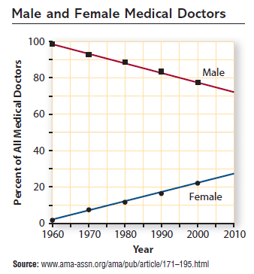

1. Using the graph above, answer the following questions.
2. How would you describe the trends shown in the graphs for males and females?
3. Why do you suppose the percentage of women doctors has been increasing over the past 40 years?
4. Would you expect the trend in the graph to continue 10 or 20 years beyond 2000?
5. What would you need to know in order to create a function that models the data trends?

The trends in percent of male and female medical doctors can be modeled by the following functions. Where *m* and *f* are the percent of male and female doctors, respectively, and *t* is the number of years since 1960.

Percentage of male doctors: 

Percentage of female doctors: 

1. Write equations or inequalities that can be used to estimate answers for each of the following questions. Do not solve.
2. In 1985, what percent of U.S. medical doctors were male?
3. When will the percent of male doctors fall to 40%?
4. How long will the percent of female doctors remain below 60%?
5. When will the percent of male doctors decline to only double the percent of female doctors?
6. Write questions about trends in percent of male and female medical doctors that can be answered by solving these equations and inequalities.
7. 
8. 
9. 
10. 
11. 

|  |  |  |
| --- | --- | --- |
| *t* | *m*(*t*) | *f*(*t*) |
| 0 | 98 | 2 |
| 10 | 92.6 | 7.4 |
| 20 | 87.2 | 12.8 |
| 30 | 81.8 | 18.2 |
| 40 | 76.4 | 23.6 |
| 50 | 71 | 29 |
| 60 | 65.6 | 34.4 |
| 70 | 60.2 | 39.8 |
| 80 | 54.8 | 45.2 |
| 90 | 49.4 | 50.6 |

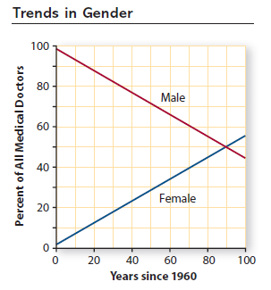

1. For each equation or inequality below, use the table or graph above to estimate the value or range of values that satisfy the given condition. In a sentence, explain what your solution tells you.

***Do not solve algebraically!***

1. 
2. 
3. 
4. 



|  |  |  |
| --- | --- | --- |
| *t* | *m*(*t*) | *f*(*t*) |
| 0 | 98 | 2 |
| 10 | 92.6 | 7.4 |
| 20 | 87.2 | 12.8 |
| 30 | 81.8 | 18.2 |
| 40 | 76.4 | 23.6 |
| 50 | 71 | 29 |
| 60 | 65.6 | 34.4 |
| 70 | 60.2 | 39.8 |
| 80 | 54.8 | 45.2 |
| 90 | 49.4 | 50.6 |

1. 
2. 
3. 
4. 
5. Write equations and inequalities to represent the following questions. Then use tables and graphs on your calculator to estimate the solutions for the equations and inequalities and explain what your solutions mean in the context of the situation. ***Do not solve algebraically.***

Percentage of male doctors: 

Percentage of female doctors: 

1. When will the percent of male doctors decline to 15%?
2. When will the percent of female doctors reach 63%?
3. How long will the percent of male doctors be above 40%?
4. What percent of U.S. medical doctors will be female in 2020?
5. Assuming that the trends continue, when will the percentage of male doctors be less than the percent of female doctors?